

Progress report

School Management System





Group 11

2022/03/04

The school management system is developed for academic and non–academic staff members and students. This system includes the student registration details, the staff member details, academic and non-academic leave details, timetable details, and the student progress details such as results, and achievement details. In this school management system project, we have been decided to build up a desktop app and web application.

In the process of contributing school management system, we used the GitHub collaboration platform. While we are developing the project GitHub is used as a code hosting platform using its repository.

First of all, we designed our entity relation(ER) diagram according to the school management system. This includes the entities, attributes, and relationships between the tables in the database. According to our school management system, there are students, staff, timetables, and subjects as the entities.

We use NetBeans and VS code as our IDEs to develop the system. MySQL is used as our database. We have already connected the database to the project and after that, we have created sign-up, sign-in, and progress bar interfaces with code.

**Project structure in NetBeans**

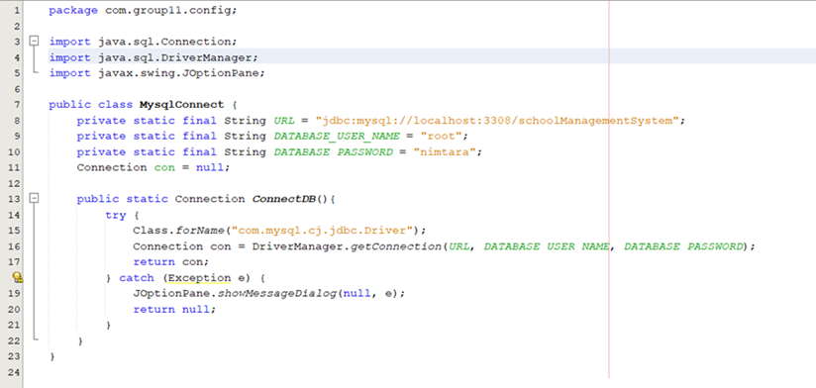**Connecting the database**

**Progress bar**

**Sign-Up**

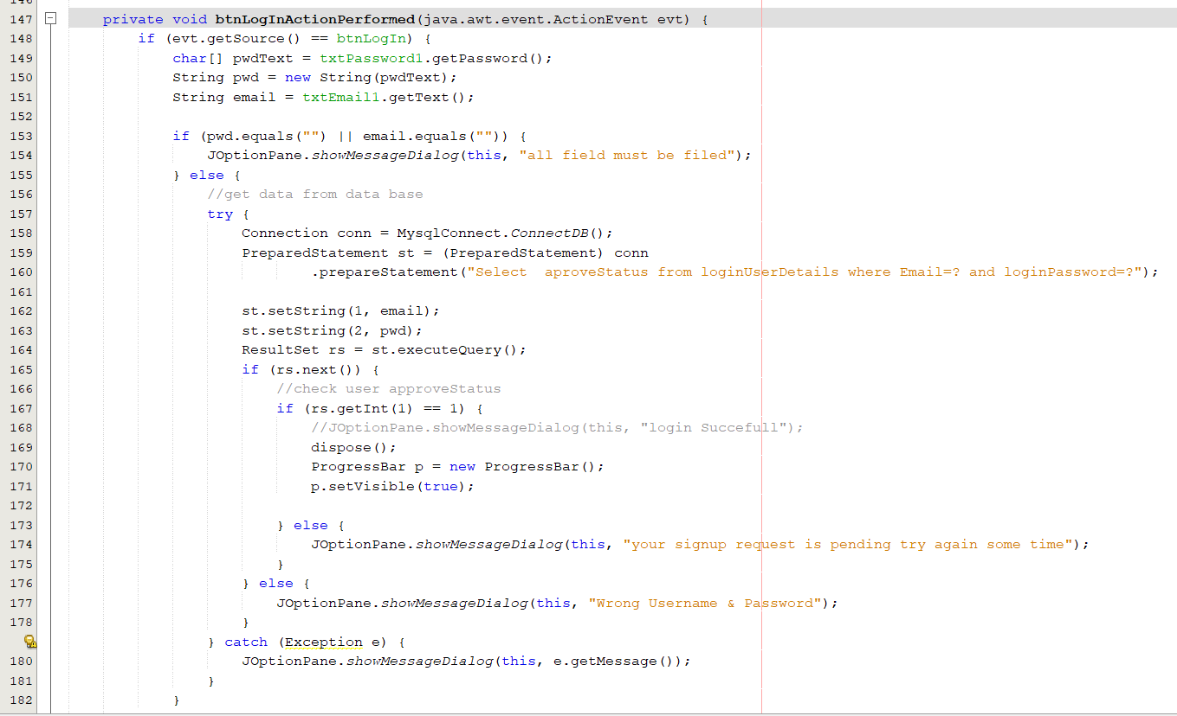**Sign-In**

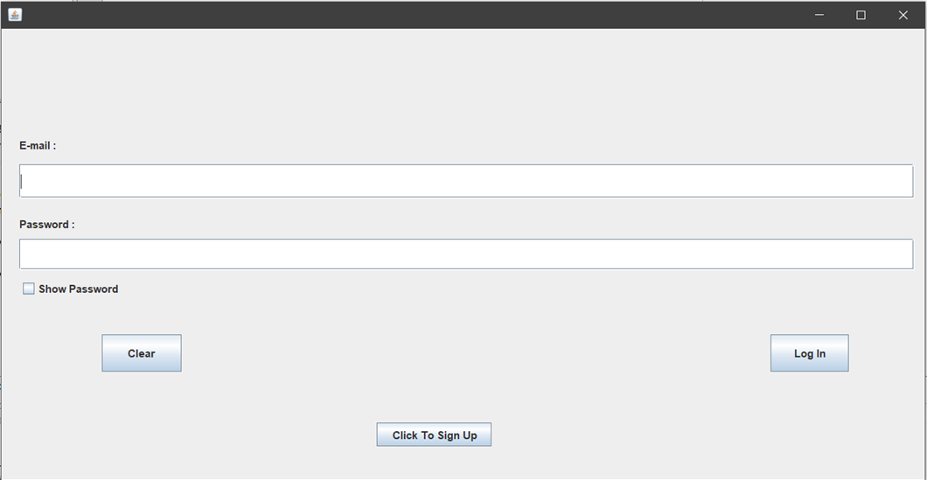

**Home interface**

**e-mail validation**

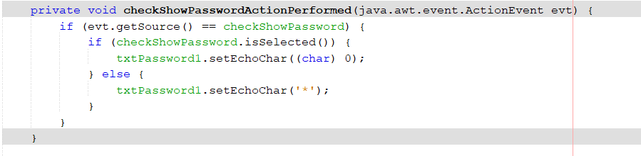**check password**

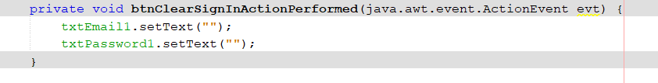**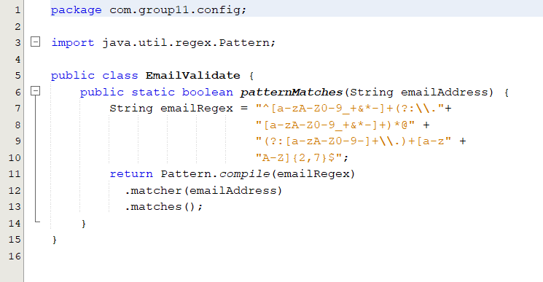Clear button**

After that, we have designed our login page in the desktop application and the graphics interface in the web application.

**Code for clear button**

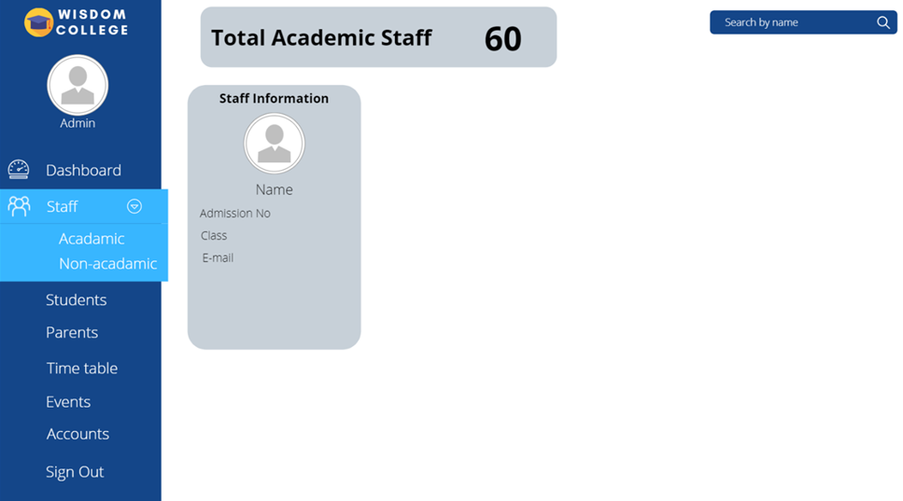

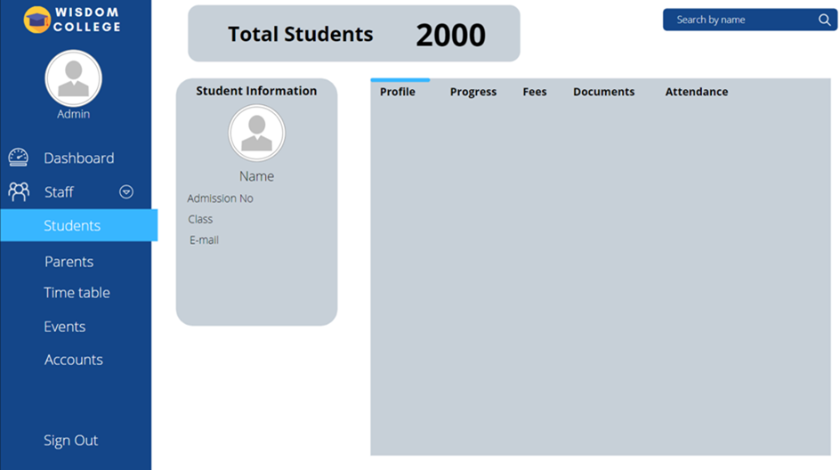

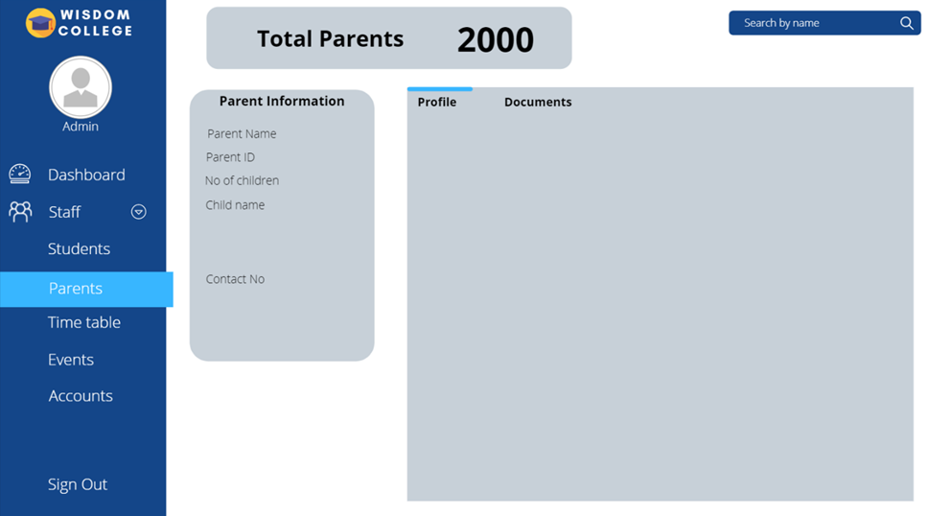

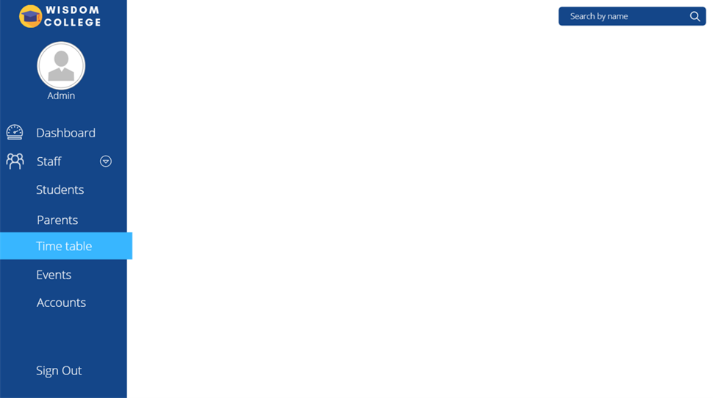

The project is still in progress and the interface designing or the coding parts are not yet completed.

**Group 11 Members**

|  |  |
| --- | --- |
| IM/2019/026 | Ariyarathne D.M.T.W. |
| IM/2019/086 | Wikramakalutota G.W. |
| IM/2019/066 | Hasarinda G.W.S. |
| IM/2019/105 | Sandeepani D.M.C. |
| IM/2019/084 | Amarasinghe A.A.K.G. |
| IM/2019/097 | Munasinghe I.G.N.N.B. |
| IM/2019/010 | Keenavinna K.A.H.P. |
| IM/2019/020 | Ravindu B.L.I. |
| IM/2019/017 | Racshan C. |